Name | Sathiya Subramaniam
Email | findsathiya@gmail.com
Current Role | Product Engineering Manager, Accenture | Number of Years/Months in the role | 15+ years (current role since Jan 2025)
Current Responsibilities | - Lead mobile engineering for Unilever's Digital Distributive Trade (DTT) platform: React Native iOS and Android apps rolled out across 10 markets.  - Manage a cross-functional team of 10+ engineers: delivery accountability, code reviews, technical workshops and 1:1 coaching.  - Define the mobile architecture standards and own the technical roadmap for the platform.  - Oversee App Store / Play Store release pipelines for market-specific builds, including the OTA (CodePush) update strategy.  - Run CI/CD and automated build workflows with Fastlane and GitHub Actions.  - Partner with product, business and client stakeholders to align engineering delivery with strategic goals; sprint planning and communication across geographies.  - Run agile delivery across design, development, QA and release, with a strong quality bar (zero critical post-release defects across markets).  - Drive agentic AI adoption in engineering: LLM-powered workflows and AI-assisted development (Claude, GitHub Copilot) to speed up delivery.

Please describe technical competences you specialize in.
Note: use N/A if no experience.
Front-end Technologies: React Native, JavaScript, Angular, Cordova, CodePush / OTA updates; iOS native: Swift, Objective-C, UIKit, Core Data, Auto Layout, XCTest; MVVM, MVC and Clean Architecture

Back-end Technologies: API design and integration, microservices architecture, Firebase; LLM integration with the Claude API and LangChain (agentic AI workflows)

Databases: Core Data (iOS) and on-device mobile storage

Cloud Platforms: Firebase (Crashlytics, Analytics), GitHub Actions and Fastlane CI/CD, App Store Connect and Google Play Console, New Relic, WebEngage, Unbxd Analytics

What is your exposure to building web applications that leverage AI/ML Models? How is the ML model integrated with the application? Please describe using a project you have worked on.
My hands-on AI exposure is with LLM-powered and agentic AI solutions rather than training classical ML models. I build agentic AI workflows with the Claude API and LangChain, and I am driving agentic AI adoption in the Unilever DTT mobile programme I lead (React Native, 10 markets), both in the engineering workflow and in how AI capabilities are brought to the platform.
How the model is integrated with the application (the pattern I follow):
- The app never calls the model directly. The mobile or web client calls our own backend endpoint. The backend holds the API keys, adds the user's context and enforces access rules.
- Orchestration layer. A LangChain agent plans the steps, calls tools that wrap existing business APIs (for example product, order or pricing services), and sends prompts to the Claude API. Responses come back as structured JSON validated against a schema, so the app renders them like any other API response.
- Guardrails. Input and output validation, no sensitive data in prompts, user confirmation before any action that changes data, timeouts, and a non-AI fallback path so the core journey always works.
- Operations. Prompt and model versions are logged with each call; latency, cost and answer quality are monitored alongside the app's existing observability tooling.
- AI-assisted engineering. In the team, GitHub Copilot and Claude are used for code generation, review support and test scaffolding to increase delivery velocity.
[Optional: name the specific agent or AI feature you built, what it does for users, and one result, e.g. time saved.]
How I would apply AI/ML to this case study (designed as an extension, not built in the submitted code):
- Price anomaly detection during ingestion. A model trained on each SKU's price history and sibling stores (e.g. gradient boosting or isolation forest) scores every changed price. The ingestion worker calls a batch inference endpoint per 500-row batch. Suspicious changes (e.g. −80% against history, out of line with the region) are held as "needs review" instead of being published to POS. The app shows "3 prices need review" with the reason and confidence.
- Column-mapping agent. When a file's header doesn't match the contract, an LLM (Claude) proposes a mapping of the unknown columns and the user confirms it on the device. This cuts whole-file rejections without guessing silently.
- Natural-language search. "milk under £2 in Manchester last week" is turned into the existing structured filters by an LLM constrained to a JSON schema. The API still enforces the user's data scope.
- Guardrails. Deterministic validation stays authoritative; models only flag or suggest; a person stays in the loop for price changes; no personal data is sent to models; model and prompt versions are written to the audit trail.

Design and implement a web application that would allow users to:

Functional Requirements
- Upload and persist pricing feeds from retail stores using CSV files which contain Store ID, SKU, Product Name, Price, Date
- Search for pricing records using various criteria and be able to edit/save changes to any record
Non-Functional Requirements
- Standard set of non-functional requirements you would expect a retail stores chain with 3000 stores across multiple countries

Please feel free to choose the technology stack and frameworks you are comfortable with and implement a single page web application.

Expected Deliverables:
- Context Diagram
- Solution Architecture
- Design Decisions
- Non-functional requirements considered and how the design addresses them
- Assumptions
- Source for the implementation

Upload the artifacts and source to your Github repository and include a reference to it as part of the response.

Solution: Retail Pricing Feeds. A React Native mobile app (iOS and Android, phone and tablet) with a Node.js pricing platform.
GitHub repository: https://github.com/fwinmaclinux/retail-pricing-feeds
The brief asks for a single-page web app. I chose a React Native app because the people who own store prices (store managers and regional pricing analysts) work on the shop floor, not at desks. They can upload a feed straight from the device, check and correct a price at the shelf, get a push notification when a feed has been processed, and keep working in stores with weak Wi-Fi. The same code runs on the web through react-native-web, so an HQ web console stays possible without a rewrite.
Deliverables. Each is covered in the annex that follows and in the repository's docs folder:
- Context diagram: Annex A · docs/01-context.md
- Solution architecture: container view, mobile app architecture, upload and edit flows, data model and API. Annex B · docs/02-solution-architecture.md
- Design decisions: 17 ADR-style decisions with alternatives and trade-offs. Annex C · docs/03-design-decisions.md
- Non-functional requirements and how the design meets each one, with sizing for 3,000 stores. Annex D · docs/04-non-functional-requirements.md
- Assumptions, including what the runnable version simplifies. Annex E · docs/05-assumptions.md
- Source: mobile/ (React Native, Expo SDK 58) and backend/ (Node.js API and ingestion), with tests. Annex F · README.md
Technology stack
- Mobile: React Native 0.88, Expo SDK 58 (New Architecture, Hermes), TypeScript, Expo Router, TanStack Query (persisted offline cache), FlashList, expo-secure-store, expo-document-picker, expo-crypto.
- Backend: Node.js, Fastify, TypeScript, zod, streaming csv-parse. Runs on PostgreSQL, with PGlite (embedded PostgreSQL) for zero-setup local runs.
- Cloud (reference): AWS regional cells: CloudFront + WAF, API Gateway, ECS/EKS, S3, SQS, Aurora PostgreSQL, ElastiCache, EventBridge, SNS. Azure equivalents are listed.
What makes it fit for 3,000 stores
- Files go straight to object storage with a pre-signed URL and are processed asynchronously by autoscaled workers. A slow store network never ties up the API.
- Partial acceptance: valid rows load, and each rejected row comes back with its line number and reasons. Re-uploads are idempotent (file SHA-256 + natural-key upsert).
- Row-level data scoping in every query (own store, own countries, or all), keyset pagination, and indexes per access path. Built for ~90M current price rows.
- Lost-update protection (ETag / If-Match, 412 with the current record) and an append-only audit trail with a mandatory reason for every manual change.
- Regional cells for data residency and blast radius; offline reads and paused writes on the device; correlation ids from device to worker.
Run locally (no Docker needed): cd backend && npm install && npm run dev, then cd mobile && npm install && npx expo start. Tests: 30 backend (CSV rules + API integration on real PostgreSQL), 13 mobile.

Annex: Case study solution, Retail Pricing Feeds (React Native)
This annex holds the full deliverables. The same content, with the source code, is in the GitHub repository (README.md and docs/). Diagrams are generated from code (docs/diagrams/build-diagrams.mjs).
A. Context diagram
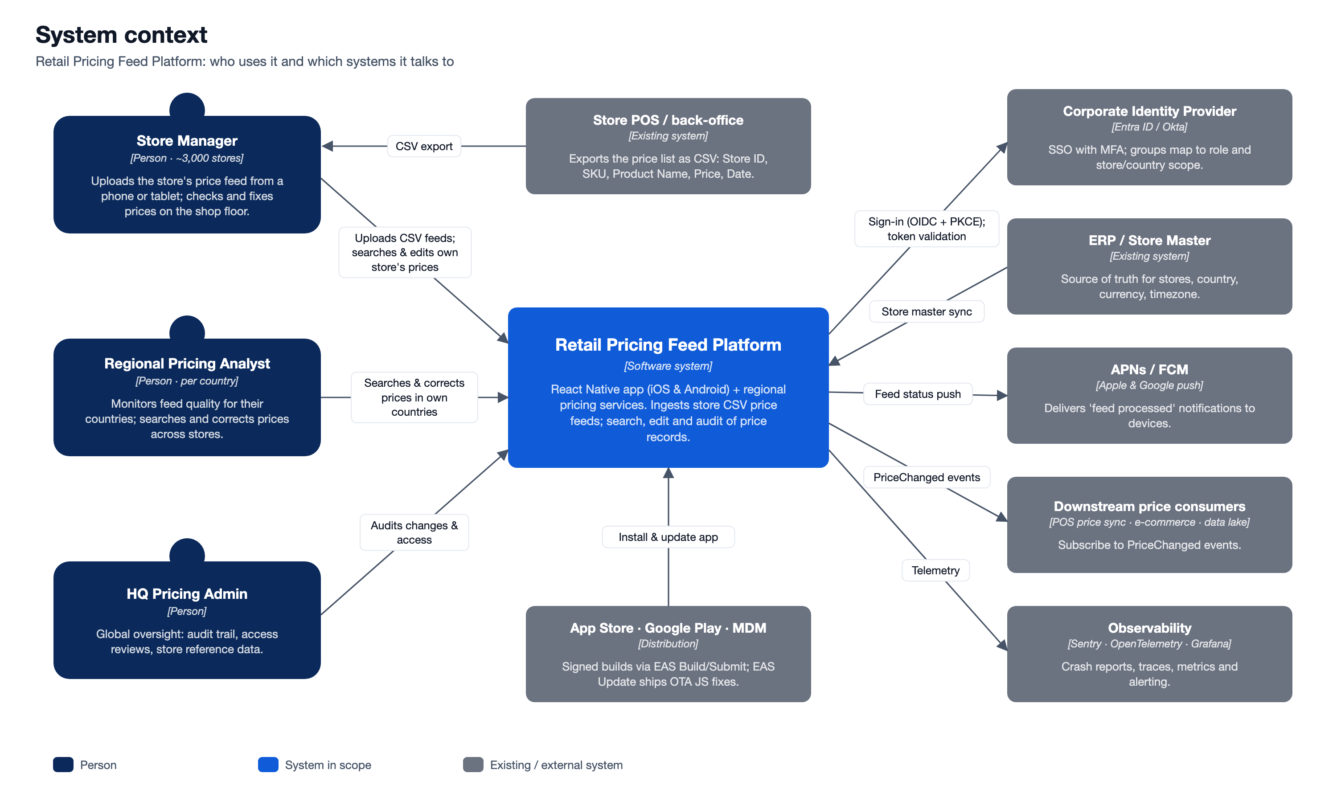
Actors
Actor | Volume (assumed) | Needs
Store Manager | ~3,000 (one or more per store) | Upload the store's feed, see which rows were rejected and why, search and correct prices for their own store only.
Regional Pricing Analyst | ~150 | Monitor feed quality for their countries, search across stores, correct prices, review the change history.
HQ Pricing Admin | ~20 | Global view, audit, access reviews, reference data.

External systems
System | Interaction
Store POS / back-office | Produces the CSV export that users upload. The app does not integrate with it directly.
Corporate Identity Provider (Entra ID / Okta) | Single sign-on with MFA (OIDC Authorization Code + PKCE). Group membership maps to role and store/country scope.
ERP / Store Master | Source of truth for stores and their country, currency and timezone. Synced nightly and on change. Currency is never taken from the uploaded file.
APNs / FCM | Push notifications such as "Your feed for GB-LON-001 has been processed, 3 rows rejected".
Downstream price consumers | POS price sync, e-commerce and the data lake subscribe to PriceChanged events. This platform does not push prices to tills itself.
App Store / Google Play / MDM | Distribution of signed builds (EAS Build/Submit). Corporate devices are enrolled in MDM (e.g. Intune). JS-only fixes ship as staged OTA updates (EAS Update).
Observability | Sentry for mobile crashes and performance; OpenTelemetry traces, metrics and logs for the backend.

B. Solution architecture
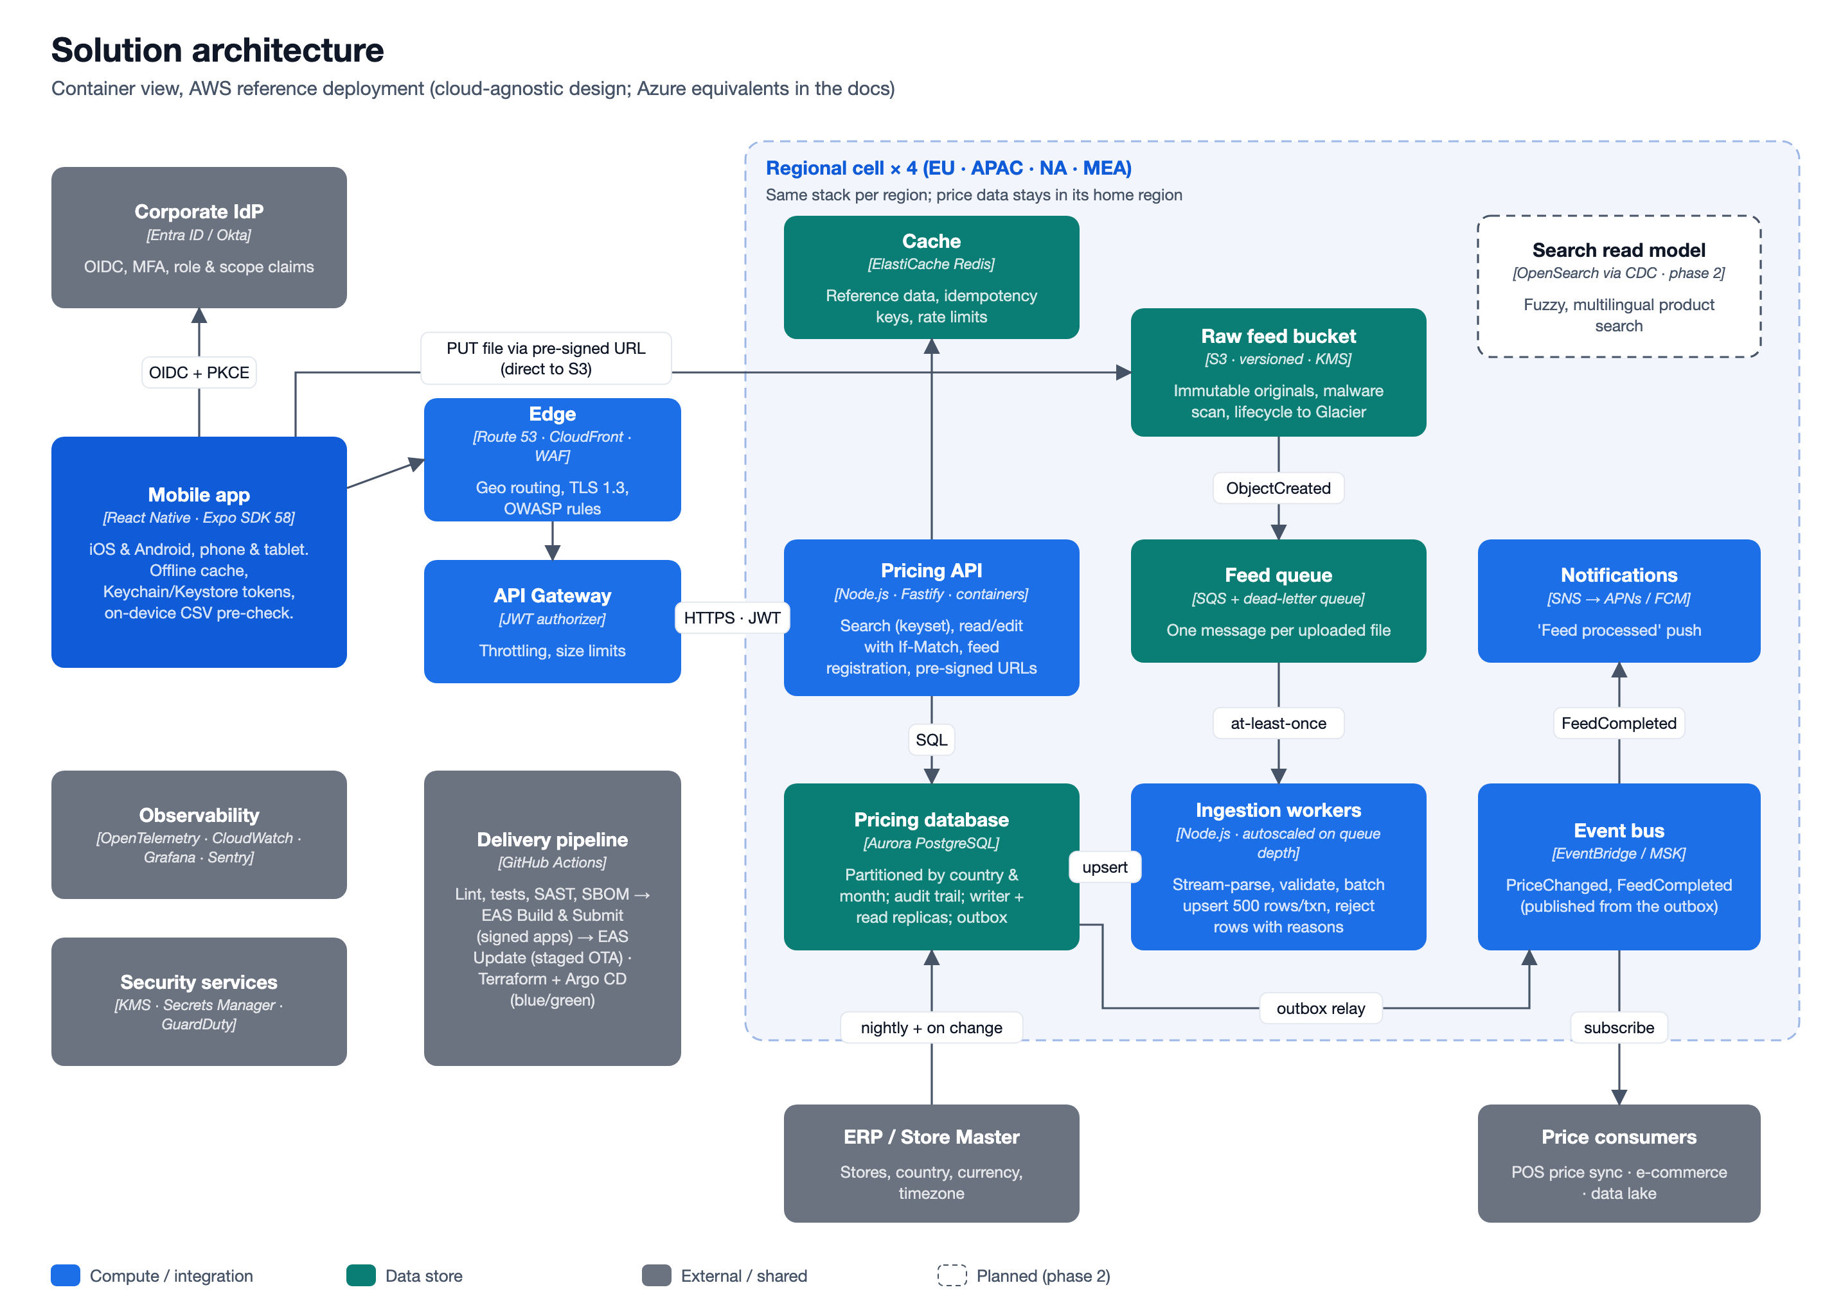
Containers
Container | Technology (AWS reference) | Responsibility
Mobile app | React Native 0.88, Expo SDK 58, TypeScript, Hermes, New Architecture | Upload with on-device pre-check, search, edit, history, feed status. Offline read cache; tokens in Keychain/Keystore.
Edge | Route 53 (geo/latency), CloudFront, AWS WAF | TLS 1.3, OWASP managed rules, bot and rate protection, routing to the home region.
API Gateway | API Gateway with JWT authorizer | Validates IdP tokens, per-user throttling, request size limits.
Pricing API | Node.js 22, Fastify, containers on ECS Fargate / EKS | Search (keyset pagination), read and edit with If-Match, feed registration, pre-signed upload URLs, audit. Stateless and horizontally scaled.
Raw feed bucket | S3: versioned, SSE-KMS, Object Lock, lifecycle to Glacier | Immutable original files (evidence and replay). Malware scan on arrival.
Feed queue | SQS with dead-letter queue | One message per uploaded file; at-least-once delivery; redrive after 5 failures.
Ingestion workers | Same Node.js codebase, separate deployment, autoscaled on queue depth | Stream-parse, validate, batch upsert, record rejected rows, publish events.
Pricing database | Aurora PostgreSQL: writer plus read replicas | System of record. price_record partitioned by country and month. Append-only audit table. Transactional outbox.
Cache | ElastiCache Redis | Store reference data, idempotency keys, distributed rate limits.
Event bus | EventBridge (or MSK/Kafka where the enterprise standard requires it) | PriceChanged and FeedCompleted, relayed from the outbox.
Notifications | SNS mobile push → APNs / FCM | "Feed processed" notification to the uploader's devices.
Search read model (phase 2) | OpenSearch fed by CDC from Aurora | Fuzzy and multilingual product search, if PostgreSQL trigram search stops being enough.

Azure equivalents
AWS | Azure
Route 53 + CloudFront + WAF | Azure Front Door + WAF
API Gateway | API Management
ECS / EKS | Azure Container Apps / AKS
S3 | Blob Storage (immutable policies)
SQS | Service Bus queues
Aurora PostgreSQL | Azure Database for PostgreSQL Flexible Server (Citus for horizontal scale)
ElastiCache | Azure Cache for Redis
EventBridge / MSK | Event Grid / Event Hubs
SNS mobile push | Notification Hubs
KMS / Secrets Manager | Key Vault
CloudWatch / X-Ray | Azure Monitor / Application Insights
GuardDuty Malware Protection for S3 | Defender for Storage

B.2 Mobile app architecture
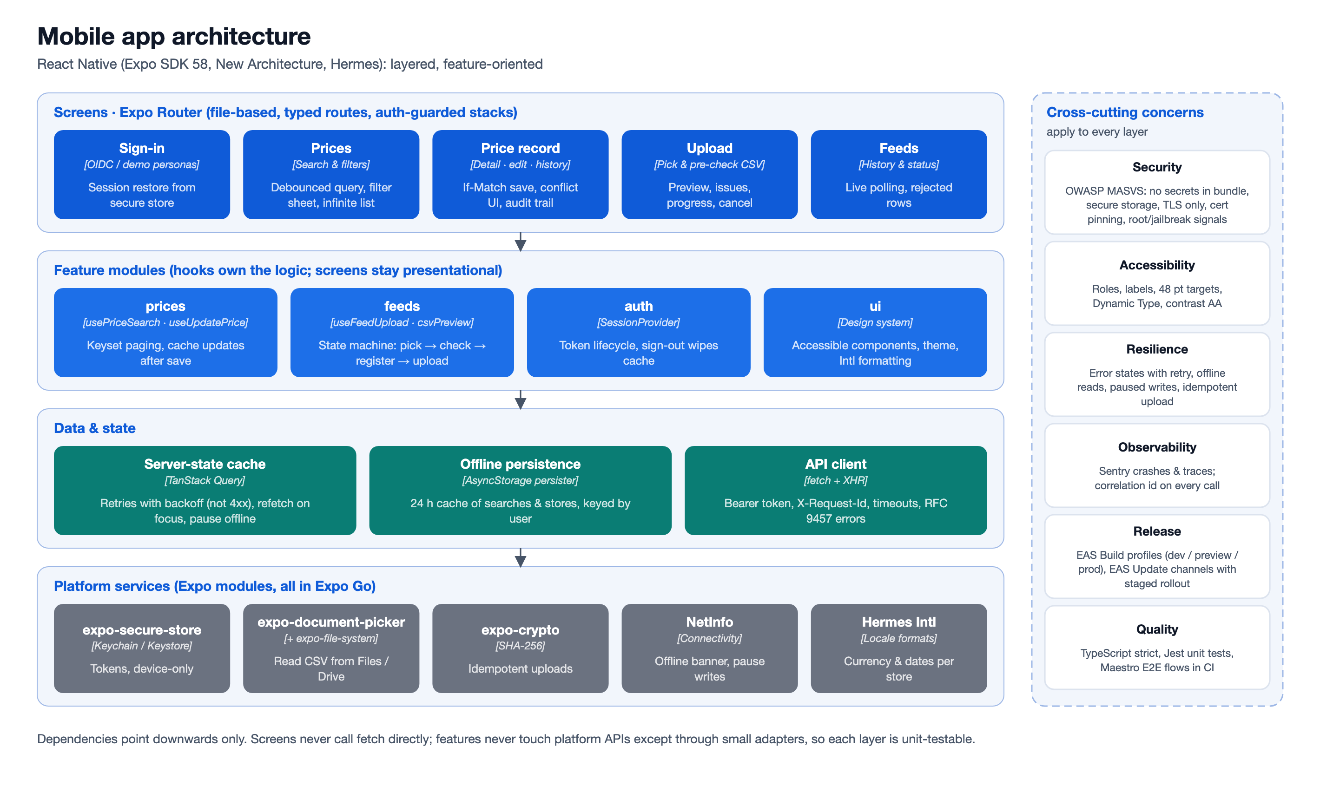
- Screens (src/app, Expo Router): file-based routes with typed links. Stack.Protected guards keep signed-out users on the sign-in screen and signed-in users out of it.
- Feature modules (src/features/*): hooks hold the logic and screens stay presentational. Examples are usePriceSearch (infinite keyset pages), useUpdatePrice (If-Match save and cache update) and useFeedUpload (an explicit state machine: pick → pre-check → register → upload → hand-off).
- Data and state: TanStack Query owns all server state: caching, retries with backoff (never for 4xx), refetch on foreground, and pausing writes while offline. The cache is persisted to device storage for 24 h. Every query key starts with the user id, so cached data cannot leak between users on a shared device. There is no Redux: almost all state here is server state.
- API client (src/api): typed endpoints, bearer token, X-Request-Id correlation id on every call, timeouts, and RFC 9457 problem details mapped to ApiError. Uploads use XMLHttpRequest because fetch exposes no upload progress in React Native.
- Platform services: expo-secure-store (tokens), expo-document-picker and expo-file-system (CSV), expo-crypto (SHA-256), NetInfo (connectivity), Hermes Intl (currency and date formatting per store).
B.3 Upload and ingestion flow
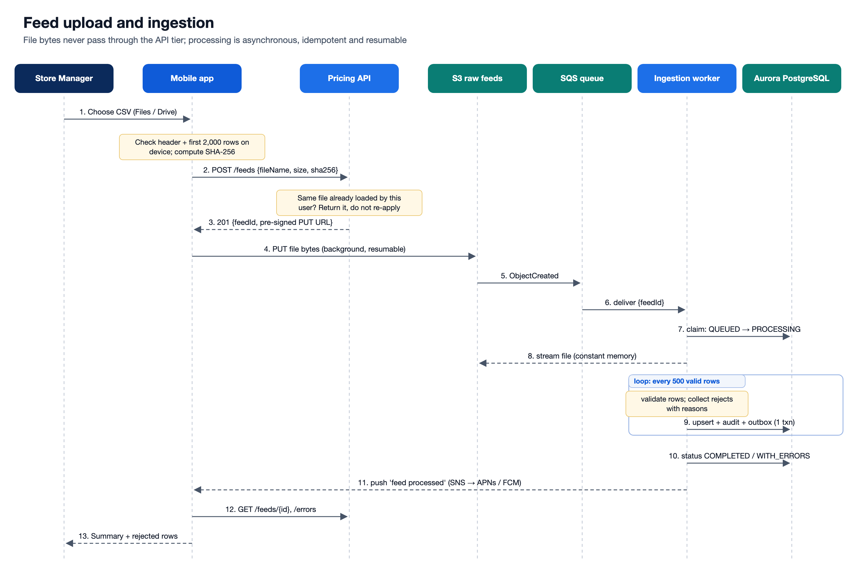
- The app parses the header and up to 2,000 rows on the device and shows missing columns and likely-bad rows before anything is sent. This is fast feedback only; the server re-validates everything.
- POST /api/v1/feeds registers the upload with the file's SHA-256. If the same user already uploaded the same content, the API returns the existing feed and nothing is applied twice.
- The app PUTs the bytes directly to S3 with a short-lived pre-signed URL. Large files use multipart upload in a native background session, so the transfer survives the app being backgrounded.
- ObjectCreated → SQS → a worker claims the feed (QUEUED → PROCESSING) and streams the file with constant memory.
- Each row is validated. Valid rows are upserted in batches of 500, each batch in one transaction together with its audit rows and outbox events. Invalid rows are stored with their line number and reasons.
- The feed ends as COMPLETED, COMPLETED_WITH_ERRORS or FAILED (bad header or no data rows). A push notification is sent, and the app shows counts (new, changed, unchanged, rejected) plus the rejected rows.
B.4 Search and edit flow
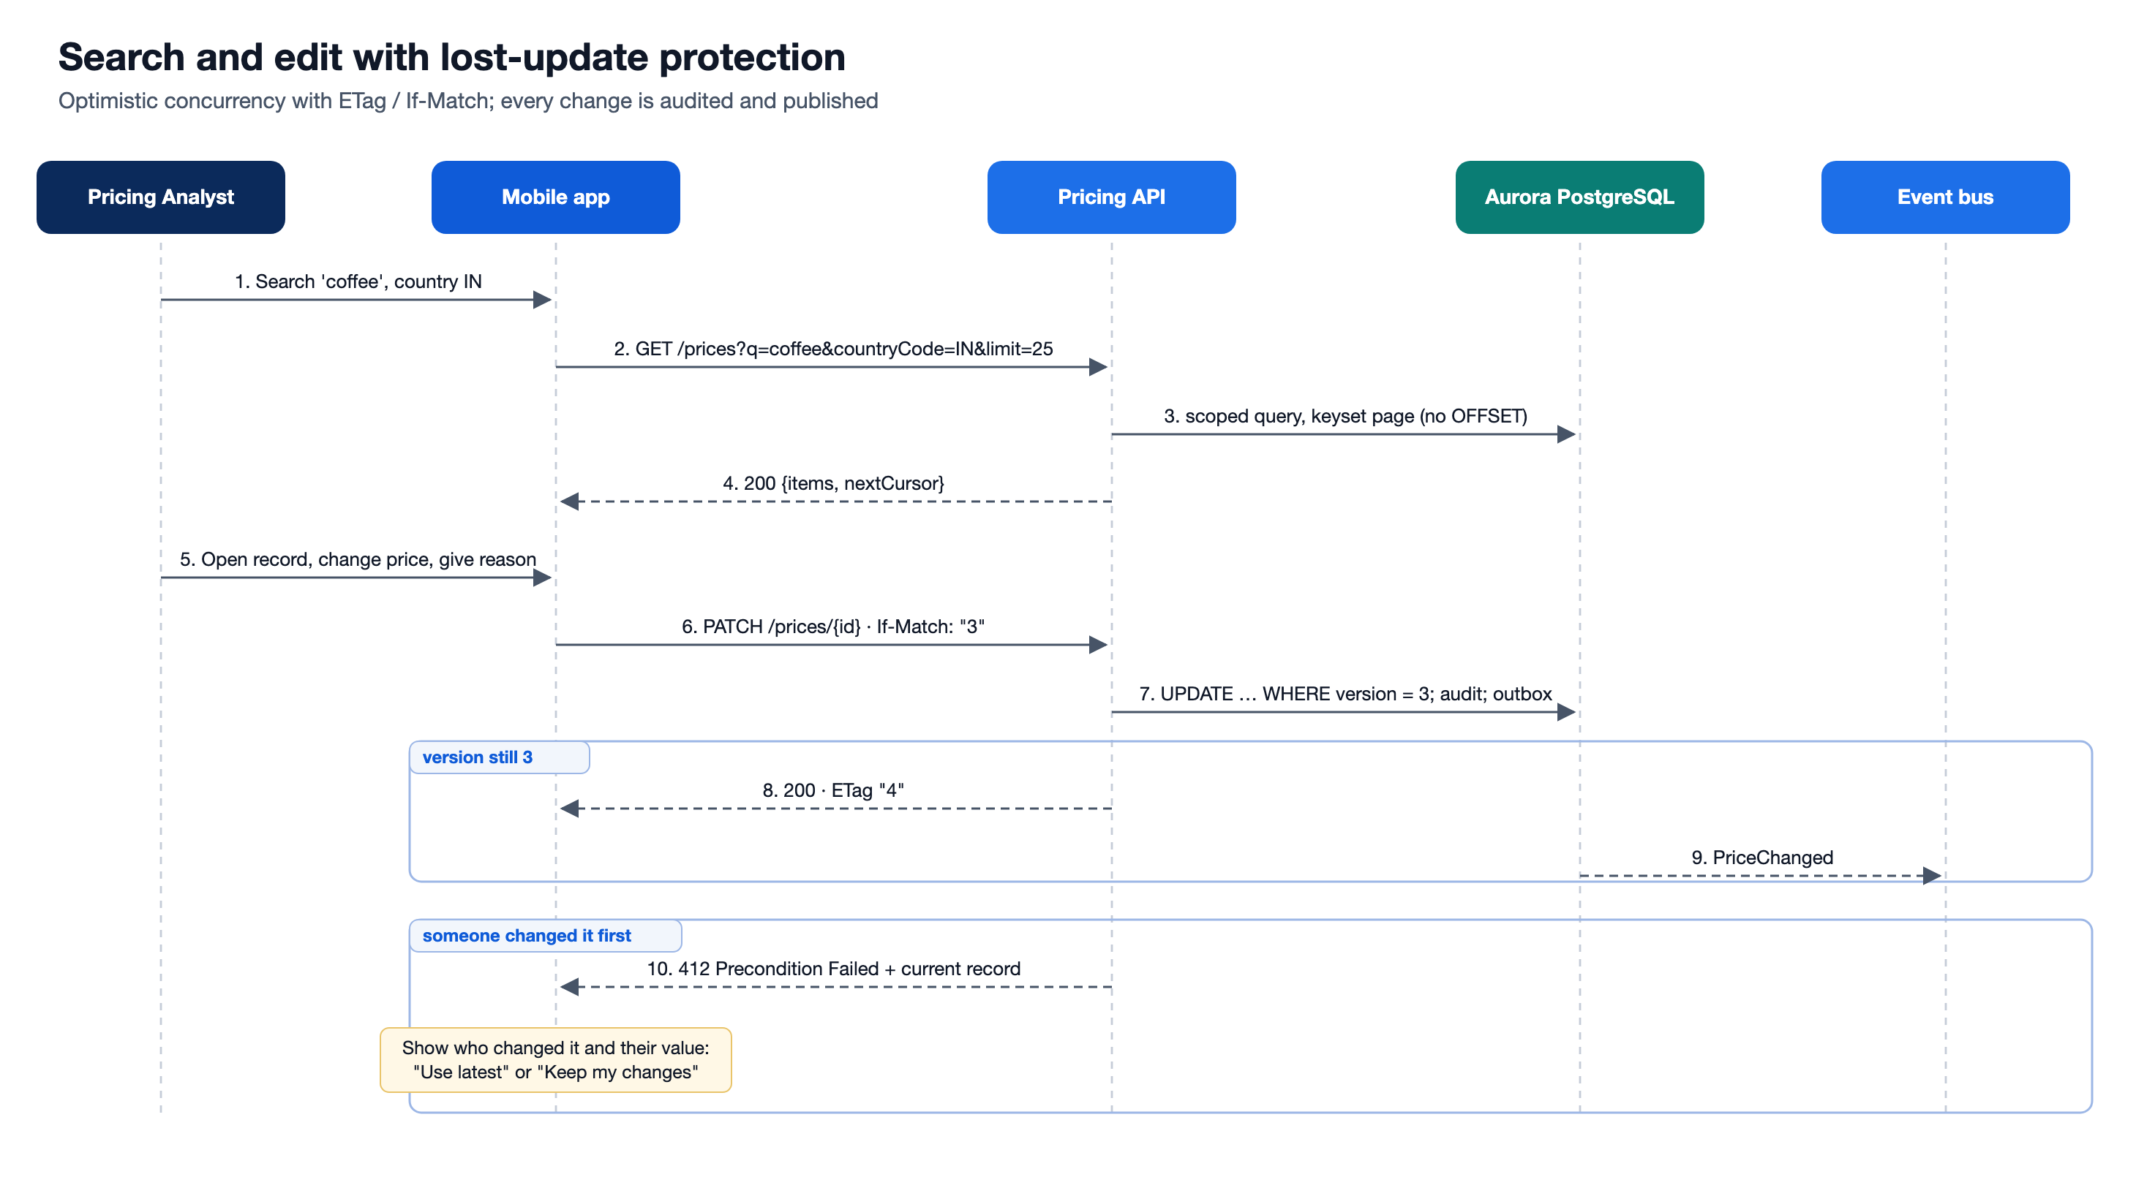
- Search combines free text (SKU prefix, or product name via a pg_trgm index) with store, country, price range and effective-date range, and sorts by date, price or SKU. Every query gets the caller's row-level scope (own store, own countries, or all) appended on the server. A filter sent by the client can never widen it.
- Paging is keyset (cursor) based. Page 500 costs the same as page 1, and inserts happening during a scroll cause no duplicates or gaps.
- Edit sends If-Match: "<version>". If anyone (a feed or a colleague) changed the record since it was opened, the API answers 412 with the current record. The app then shows who changed it and to what, and lets the user choose Use latest or Keep my changes. Every save needs a reason and is written to the audit trail in the same transaction.
B.5 Data model
Table | Key columns | Notes
store | store_id PK, country_code, currency, timezone, region | Synced from ERP. Drives currency and data scoping.
price_feed | feed_id PK, uploaded_by, checksum_sha256, status, row counters | Unique (uploaded_by, checksum) index for idempotent uploads.
price_feed_error | (feed_id, row_number) PK, raw_row, messages | Capped at 1,000 stored rows per feed; all rejections are counted.
price_record | id PK, unique (store_id, sku, effective_date), price NUMERIC(14,4), currency, version | Production: PARTITION BY LIST (country_code), then RANGE (effective_date) monthly. Indexes per access path, plus a trigram GIN index on product_name.
price_record_audit | audit_id PK, price_record_id, action, old_values, new_values, changed_by, change_reason | Append-only. CREATED, FEED_UPDATE, MANUAL_EDIT.

B.6 API (v1)
Method & path | Purpose
POST /api/v1/feeds | Register an upload {fileName, sizeBytes, checksumSha256} and get the upload URL (or the existing duplicate).
PUT /api/v1/feeds/{id}/content | Local stand-in for the S3 pre-signed PUT (streamed to storage, checksum verified).
GET /api/v1/feeds · /{id} · /{id}/errors | Upload history, live status and counters, rejected rows with reasons.
GET /api/v1/prices?q&storeId&sku&countryCode&minPrice&maxPrice&dateFrom&dateTo&sort&order&limit&cursor | Scoped, keyset-paginated search.
GET /api/v1/prices/{id} | Record with ETag: "<version>".
PATCH /api/v1/prices/{id} | Edit {price?, productName?, reason} with If-Match. Returns 412 + current record on conflict, 428 without If-Match.
GET /api/v1/prices/{id}/history | Audit trail.
GET /api/v1/stores, GET /api/v1/me | Scoped reference data and the caller's identity.
GET /health/live, /health/ready | Liveness and readiness probes.

C. Design decisions
# | Decision | Alternatives considered | Why / trade-off
DD-01 | React Native with Expo (SDK 58, New Architecture, Hermes) for one iOS + Android codebase | Native Swift + Kotlin; Flutter; responsive web/PWA | One TypeScript codebase and skill set shared with the backend. Expo modules cover file picking, secure storage, crypto and push without custom native code. EAS Build/Submit/Update gives signed builds and staged OTA fixes. A PWA cannot reliably do background uploads, push on iOS or Keychain storage. Trade-off: native modules outside Expo need a dev build (already the plan for release).
DD-02 | Mobile-first, not a web SPA, while keeping the web door open | Web SPA (as the brief suggests) | The users are store managers on the shop floor. The same code runs on react-native-web, so an HQ web console can follow without a rewrite.
DD-03 | Direct-to-S3 upload with a pre-signed URL, then asynchronous ingestion | Multipart POST through the API; synchronous parse-and-save | Large files on flaky store networks should not tie up API instances or hit gateway timeouts. Uploads resume in the background, and processing scales independently on queue depth. Trade-off: the user waits for a status (polling or push) instead of an instant answer. The on-device pre-check covers the common mistakes up front.
DD-04 | Idempotency end to end: file SHA-256 per uploader, natural-key upsert on (store, SKU, effective date), unchanged rows skipped | Rely on exactly-once delivery; dedupe by file name | SQS and retries are at-least-once. The same file or message can arrive twice without double-applying or bumping versions.
DD-05 | Partial acceptance with row-level rejects. Only a bad header fails the whole file | All-or-nothing transaction per file | One bad row should not block 29,999 good prices. Every rejected row is reported with its line number and reasons so the store can fix only those.
DD-06 | PostgreSQL (Aurora) as system of record, partitioned by country and month. Search uses composite indexes + pg_trgm. OpenSearch only if needed (CDC) | DynamoDB; search-engine-first; one big unpartitioned table | Search is ad-hoc across several criteria, and edits need transactions with their audit rows. A relational model fits both. Partitioning keeps indexes small, prunes country-scoped queries and makes retention a partition drop. Trade-off: fuzzy multilingual search is weaker than OpenSearch, so it is planned as a phase-2 read model.
DD-07 | Keyset (cursor) pagination, no total counts | OFFSET/LIMIT with COUNT(*) | OFFSET gets slower with every page and COUNT(*) is expensive at 90M+ rows. Infinite scroll on mobile doesn't need a total.
DD-08 | Optimistic concurrency: version column, ETag / If-Match, 412 with the current record | Last write wins; pessimistic locks | Prevents lost updates between a feed and a person, or two people. Locks are a bad fit for mobile clients that go offline. The conflict UI lets the user choose deliberately.
DD-09 | Append-only audit trail and transactional outbox | Audit via logs; publish events directly from code | Price changes are business- and compliance-relevant: who, what, when and why. The outbox makes "saved and published" atomic.
DD-10 | Regional cells (EU, APAC, NA, MEA) with the same infrastructure-as-code | One global deployment; per-country deployments | Meets data-residency rules (e.g. GDPR) and contains failures. Per-country stacks would multiply operations cost about 15×.
DD-11 | Security model: OIDC Authorization Code + PKCE, short-lived access tokens in Keychain/Keystore, row-level scope enforced in SQL on every query | API keys; client-side filtering; session cookies | Never trust a client filter: even a crafted request can only see its own scope. Scope comes from IdP claims and maps to the store hierarchy.
DD-12 | Money as NUMERIC and decimal strings end to end. Currency comes from the store master, not the file | Floats; a currency column in the CSV | Avoids rounding errors, and a mistyped currency in a file cannot mis-price a store.
DD-13 | Strict, explicit feed contract: header by name (any order, common aliases), UTF-8 (BOM tolerated), ISO-8601 dates, . decimal separator | Guess formats per country | 01/02/2026 is ambiguous across countries. Rejecting it with a clear message is safer than guessing, and the message tells the user exactly what to change.
DD-14 | Server state in TanStack Query (persisted), local UI state in components. No Redux | Redux Toolkit / RTK Query; MobX | Nearly all state is server state. TanStack Query gives caching, retries, offline pause and persistence with very little code.
DD-15 | Modular monolith API plus a separate worker deployment from one codebase | Microservices per capability | The team and the domain are small. Module boundaries (feeds, prices, stores, auth) are explicit, so they can be split out later without a rewrite.
DD-16 | Ports and adapters for infrastructure: Database, BlobStore, JobQueue. Local adapters are PGlite (embedded PostgreSQL), disk storage and an in-process queue | Docker-only local setup | Reviewers can run everything with npm install && npm run dev, against the same SQL that runs on Aurora. Production adapters (pg, S3, SQS) sit behind the same interfaces.
DD-17 | Release safety for mobile: EAS Update channels with staged rollout, a minimum-supported-version check, feature flags | Store releases only | JS fixes reach 3,000 stores in hours, not days of review. Native changes still go through store or MDM releases.

D. Non-functional requirements
Sizing that drives the design
Dimension | Estimate
Stores / countries / regions | 3,000 / ~15 / 4 cells
Active SKUs per store | ~30,000 (5k–80k)
Feed pattern | Daily delta (~10% of SKUs) plus a weekly full file, uploaded mostly in a 2-hour morning window per region
Rows ingested per day | ~22M on average (9M delta + 13M from the weekly full files spread across the week)
Peak ingestion (largest region, ~1,200 stores) | ~1,200 rows/s on a normal morning; ~5,000 rows/s if every store sends its full file in the same window → designed for 10,000 rows/s per region
Price records | ~90M current; ~9M real changes/day → ~3.3B history rows/year (≈ 1 TB with indexes); 13 months online, older partitions archived to the data lake
Users / peak concurrency | ~5,000 / ~1,500
Search traffic (peak) | ~200 requests/s per region → designed for 500

Requirements and how the design addresses them
Category | Requirement (target) | How the design addresses it | In this implementation
Scalability | 10k rows/s ingestion per region; 500 search req/s; grow to 5,000 stores without redesign | Direct-to-S3 upload; queue-buffered workers autoscaled on queue depth; batch upserts (COPY + MERGE at scale); stateless API behind a load balancer; read replicas for search; partitioning by country and month | Streaming CSV parser, batched upsert (500 rows per round trip), stateless API, keyset paging
Performance | Search p95 < 400 ms server-side and < 1 s on device over 4G; save p95 < 300 ms; 30k-row feed processed < 60 s after upload; app cold start < 2 s on a mid-range Android | One index per access path plus trigram for names; scope-first queries; debounced search; FlashList virtualization; Hermes; cached reference data | Indexes in 001_initial_schema.sql; 350 ms debounce; FlashList; 24 h stores cache
Availability | 99.9% for search and edit (stores span every timezone, so effectively 24×7); ingestion may be delayed but never loses an accepted file | Multi-AZ everything; regional cells; health probes and rolling/blue-green deploys; DLQ plus redrive; queued jobs survive restarts | /health/live and /health/ready; jobs re-queued on startup; graceful shutdown waits for running jobs
Resilience and offline | Stores with weak Wi-Fi keep working: read recent data offline; never lose an edit or upload | Persisted query cache; mutations pause offline and resume; resumable background uploads; retries with backoff (never on 4xx); idempotent server operations | Persisted TanStack cache, offline banner, paused-mutation notice, upload cancel/retry, checksum dedupe
Data integrity | No lost updates; no double-applied feeds; exact money | Optimistic concurrency (If-Match); natural-key upsert; SHA-256 checksum verified server-side; NUMERIC money; currency from the store master; per-batch transactions with audit | All implemented and covered by API tests
Security | SSO + MFA; least privilege; OWASP ASVS L2 (API) and MASVS L1/L2 (mobile); encryption in transit and at rest | OIDC + PKCE; RBAC + row-level scope in SQL; WAF, rate limits, size limits; TLS 1.3; KMS; short-lived pre-signed URLs; malware scan on upload; CSV formula-injection guard; Keychain/Keystore tokens; certificate pinning, jailbreak/root signals and MDM in release builds; dependency scanning and SBOM in CI | JWT auth, scope in every query, Helmet headers, rate limit, upload size cap, formula guard, secure-store tokens, problem details without stack traces
Privacy and data residency | Personal data stays in-region (GDPR, India DPDP); minimal personal data | Regional cells; only user ids in records and audit; logs redact Authorization; Sentry PII scrubbing | Authorization header redacted from logs
Auditability and compliance | Every price change traceable for 7 years (who, what, when, why); original files kept | Append-only audit table; mandatory change reason; immutable versioned S3 with Object Lock; audit archived to the data lake | Audit on create, feed update and manual edit; reason required; history screen
Observability | Detect and diagnose problems within minutes; SLOs per journey | Correlation id from device to worker; structured JSON logs; OpenTelemetry traces; metrics (queue depth, rows/s, reject rate, p95 latency, crash-free sessions); SLO dashboards and alerts | X-Request-Id on every call and in logs; per-feed ingestion metrics logged
Usability and accessibility | Usable one-handed on the shop floor; WCAG 2.2 AA equivalent | Large touch targets; plain-language errors with the exact row and fix; screen-reader roles and labels; Dynamic Type; tablet-friendly max widths | Accessible roles and labels on interactive elements, 48 pt buttons, row-level messages
Internationalisation | Multiple countries, currencies, languages and timezones; RTL-ready (e.g. Arabic for UAE) | Store-driven currency and timezone; Intl formatting by device locale; i18next string catalogs; UTF-8 everywhere; RTL layout testing | Intl currency and date formatting; JPY/INR zero-decimal handling in sample data; UTF-8 + BOM tolerant parsing
Maintainability and testability | New team members productive in days; safe refactoring | TypeScript strict end to end; feature modules; ports and adapters; ADRs; unit, integration and E2E (Maestro) tests in CI; forward-only migrations | 30 backend tests (validation + API integration on real PostgreSQL via PGlite), 13 mobile unit tests, strict typecheck on both
Deployability | Daily backend releases with no downtime; mobile hotfix within hours | Blue/green or rolling deploys; expand-contract migrations; EAS Update staged rollout with rollback; feature flags; minimum-version gate | Versioned migration runner; EAS-ready Expo config
Cost efficiency | Cost proportional to load; peak-hour scaling | Autoscaled workers (to zero off-peak); Graviton; S3 lifecycle to Glacier; partition drop for retention; read replicas only in large regions | n/a (design)
Device support | iOS 16+ and Android 8+ phones and tablets; corporate and BYOD (MDM) | Expo SDK 58 baseline; responsive layouts (max-width content on tablets); portrait and landscape | orientation: default, supportsTablet, constrained content widths

E. Assumptions
Business
- Date is the price's effective date in the store's local calendar. A record is identified by (Store ID, SKU, Date).
- Uploading the same (Store ID, SKU, Date) again updates that record. Latest write wins, with the version bumped and the change audited. Identical rows are skipped, with no version bump.
- Feeds may be delta or full. At production scale the ingestion also suppresses rows whose price and name match the price already in effect, which keeps history growth to real changes. Search then supports "as of date" queries (latest effective date ≤ the requested date).
- Editable fields are Price and Product Name. Store ID, SKU and Date identify the record: to "move" a price, upload a correct row. Every edit needs a short reason.
- A feed updating a manually edited record overrides it. The audit trail shows both changes. A "manual override lock" or maker-checker approval for large changes is a possible follow-up, not in scope.
- Product Name is stored as received per store (no product master in scope). Prices are shelf prices including tax, as sent by the store.
- Currency comes from the store master, never from the file. Prices are non-negative with up to 4 decimals.
- Pushing prices to POS tills, promotions, competitor pricing and price approval workflows are out of scope. Downstream systems consume PriceChanged events.
Users and access
- About 3,000 store managers, ~150 regional analysts and ~20 HQ admins. Store managers see and change only their own store(s); analysts only their countries; admins everything.
- A corporate IdP (Entra ID or Okta) with MFA already exists, and its groups can express role plus store/country scope.
- Devices are company-managed through MDM, or BYOD with an MDM app-protection policy. iOS 16+ and Android 8+.
Data and volumes
- About 30,000 active SKUs per store, ~10% changing daily, plus a weekly full file. Most uploads happen in a 2-hour morning window per region (see the sizing table in Non-functional requirements).
- Files are UTF-8 CSV with a header row, at most 50 MB (~500k rows) per upload from a device. Larger HQ-level consolidated feeds use a server-to-server path (SFTP or API into the same bucket and queue), not the mobile app.
- Dates use ISO-8601 YYYY-MM-DD and decimals use .. Other formats are rejected with a clear, row-level message rather than guessed.
Technology and delivery
- AWS is the reference cloud. An Azure mapping is given in the solution architecture, and the design uses no AWS-only concepts.
- The ERP is the source of truth for the store master and can feed a nightly or on-change sync.
- Mobile release uses EAS (Build, Submit, Update). Enterprise distribution is through the App Store / Google Play (private or managed) and MDM.
Simplifications in the runnable implementation
Production design | Implemented here as | Why
OIDC SSO via the corporate IdP | Demo personas (/auth/dev-login) issuing short-lived HS256 JWTs with the same claims | No IdP available. Scope enforcement is identical.
S3 pre-signed PUT | PUT /api/v1/feeds/{id}/content, streamed to disk with SHA-256 verification | Same client contract (upload.url / method / headers).
SQS + worker deployment | In-process queue with the same at-least-once, idempotent contract; recovers queued jobs on restart | Zero infrastructure to run locally.
Aurora PostgreSQL (partitioned) | PGlite (PostgreSQL in WASM), or real PostgreSQL via DATABASE_URL | Same SQL; partitioning described in the migration header.
Push notifications | Live polling of feed status while the screen is open | Push needs APNs/FCM credentials.
COPY + MERGE bulk load | Batched INSERT … ON CONFLICT with audit in one statement per batch | Same semantics; simpler at demo volumes.
Background/resumable native upload | XMLHttpRequest PUT with progress and cancel | Runs in Expo Go without a custom dev build.

F. Source code and how to run it
Repository: https://github.com/fwinmaclinux/retail-pricing-feeds
Screen | What it does
Sign-in | Corporate SSO in release builds. The demo build offers personas with different data scopes: store manager, country analyst, HQ admin.
Prices | Debounced search by product name or SKU. Filter sheet for country, store, effective date and price range, plus sort. Infinite list with keyset paging, pull to refresh, offline cache.
Price record | Price in the store's currency, lineage (feed or manual edit), version. Edit with validation, a large-change warning and a mandatory reason. Conflict handling if someone else saved first. Change history.
Upload | Pick a CSV from Files or Drive, or use a generated sample feed. On-device pre-check (columns, likely-bad rows, preview), then upload with progress and cancel. Duplicate files are recognised.
Feeds | Upload history with live status, counts (new, changed, unchanged, rejected) and every rejected row with its reasons.
Account | User, role, stores in scope, API endpoint, sign out (wipes the cache).

Run locally (no Docker or database install)
- API: cd backend && npm install && npm run dev. Serves http://localhost:4000 and seeds 12 stores in 8 countries with ~1,440 prices through the real ingestion path.
- Mobile app: cd mobile && npm install && npx expo start, then press i (iOS Simulator), a (Android emulator) or w (web), or scan the QR code with Expo Go. Requires Node.js 22.13+.
- Tests: npm test in backend/ (30 tests: CSV contract + API integration on real PostgreSQL) and in mobile/ (13 tests); npm run typecheck in both.
Repository layout
- backend/src/feeds: upload registration, streaming ingestion, CSV contract, job queue
- backend/src/prices: scoped keyset search, If-Match edits, audit history
- backend/src/auth: JWT auth, roles, row-level scope · backend/src/db: PostgreSQL/PGlite adapter, migrations, seed
- mobile/src/app: screens (Expo Router) · mobile/src/features: prices and feeds modules · mobile/src/api: typed client, upload with progress
- docs/: deliverables and diagrams · sample-data/: example CSV feeds (valid delta, one with errors, 25k-row full feed)

